**Moulik Tammana**

**Q12. Implement ACLs to restrict traffic based on source and destination ports. Test rules by simulating legitimate and unauthorized traffic.**

**We have configured to restrict telnet request for IP addresses in the range od 192.168.1.64 to 192.168.1.255.**

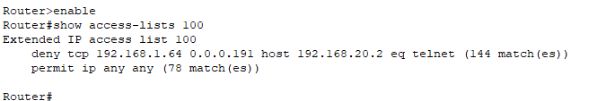

**This is the command used to for restriction of the packets through the router.**

**The IP which was successful:**

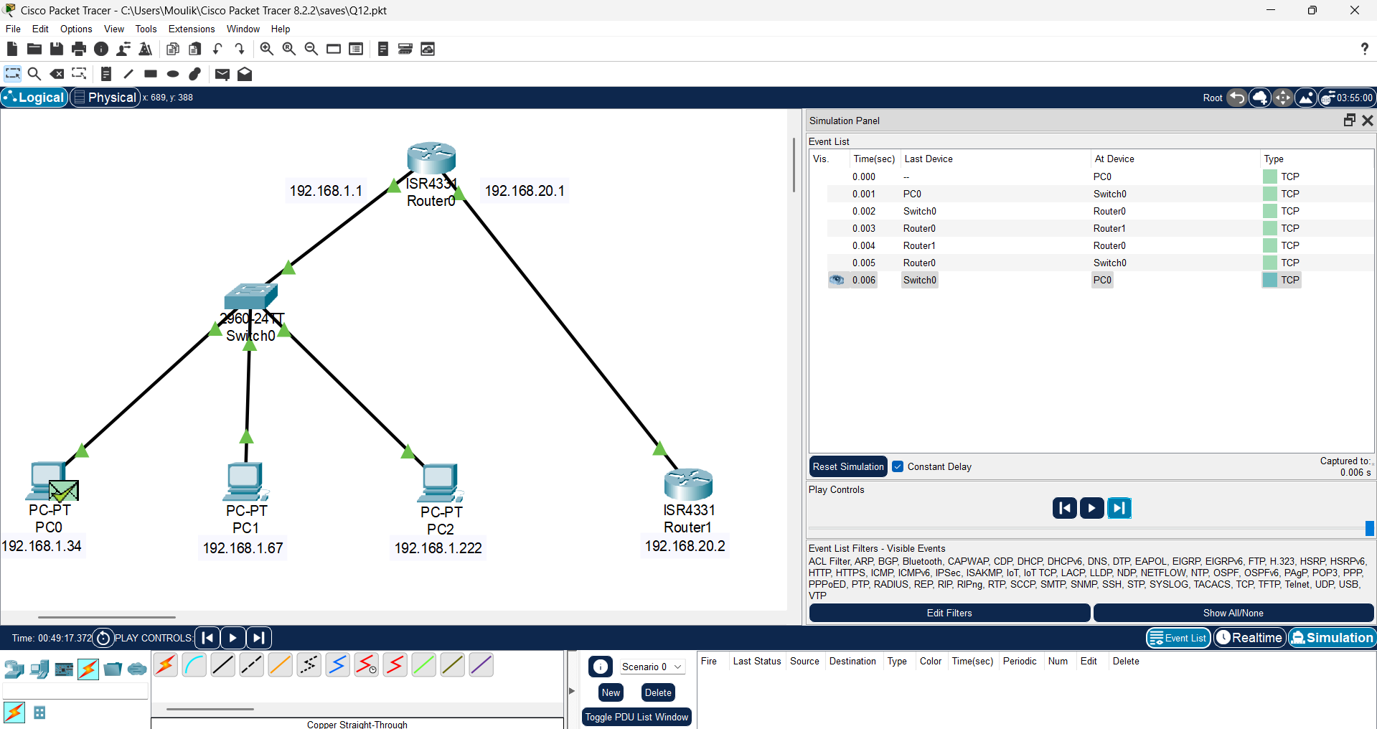

**The failure case of the IP:**

